10G Fiber Optical Quad Port PCI Express Network Adapter XL710
S6300-4SX710

Product Overview:

Extending Intel Virtualization Technology Beyond Server Virtualization to the

Network with Hardware Optimizations and Offloads for the Rapid Provisioning

of Networks in an Agile Data Center.

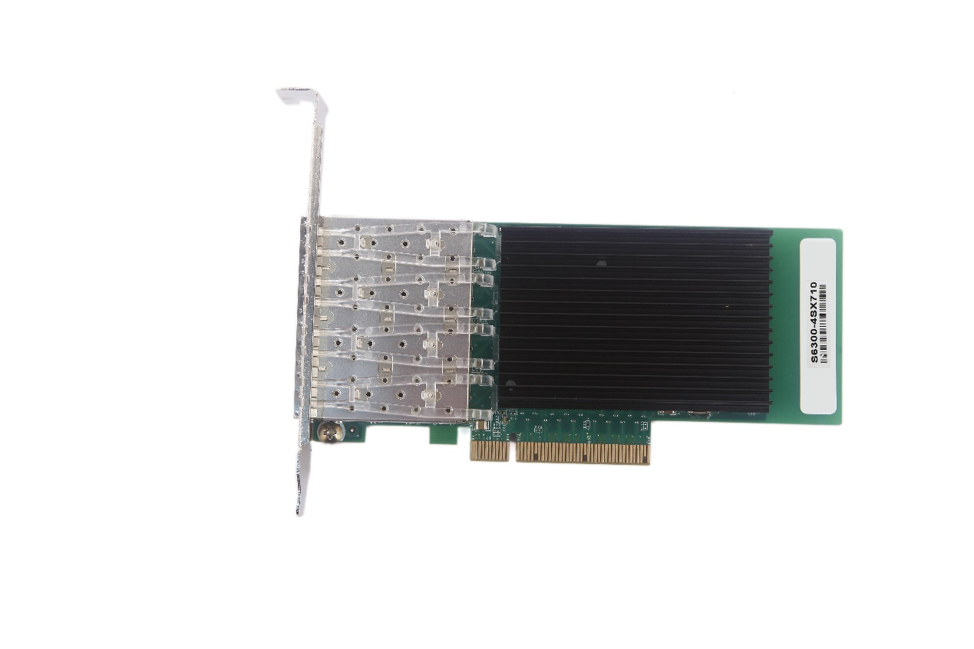

Key Features

• Quad-port 10GbE adapters
• Supports 4x10GbE configurations
• PCI Express* (PCIe*) 3.0, x8
• Exceptional low power adapters
• Network Virtualization offloads including VXLAN, NVGRE, and Geneve 1
• Intel® Ethernet Flow Director (Intel® Ethernet FD ) for hardware-based application traffic steering
• Data Plane Development Kit (DPDK) optimized for efficient packet processing
• Excellent small packet performance for network appliances and Network
Functions Virtualization (NFV)
• Intelligent offloads to enable high performance with Intel® Xeon® processor-based servers
• I/O virtualization innovations for maximum performance in a virtualized server
• Unified networking providing a single wire support for LAN and storage: NAS

Leading 10 GbE Performance

• Small Packet Performance: Maintains wire-rate throughput on smaller payload sizes
• Bulk Transfer Performance: Delivers line-rate performance with low CPU usage for large application buffers
• Virtualized Performance:Alleviates hypervisor I/O bottlenecks by providing flow separation for Virtual Machines (VMs)
• Network Virtualization:Network virtualization overlay offloads including VXLAN, NVGRE,and Geneve
• Storage Performance:Enables competitive performance with native
OS drivers and intelligent offload for NAS (NFS, SMB), and SAN (iSCSI)

Basic Information:

Products Name |  | 10Gbps Quad Port Gigabit Ethernet Server Network Card
Products Type |  | S6300-4SX710
Chipset |  | Intel XL710-BM1
Bus Interface |  | x8 (x16) PCIe* 3.0
Whole Duplex |  | Compatible Whole Duplex and Half Duplex
Network Interface Type |  | SFP+ Slot*4, LC Fiber
Transmission Speed |  | 10Gbps
Transmission Medium Type |  | LC Fiber, Comply with MMF62.5/50 Micron
Network Standard |  | IEEE802.3 10GBASE-SR,10GBASE-LR
Date Rate |  | 40G/s
Fiber Module |  | 10G-SFP+-SR  10G-SFP+-LR
Long-range Awaken Function |  | Support
Operating System |  | IA-32 | X86-64 |  | IA-64
Windows Server2012 R2* |  | N/A | X |  | N/A
Windows Server2012 R2 Core |  | N/A | X |  | N/A
Windows Server2012 |  | N/A | X |  | N/A
Windows Server2012 Core |  | N/A | X |  | N/A
Windows Server2008 R2* |  | N/A | X |  | N
Windows Server2008 R2 Core |  | N/A | X |  | N
Linux* Stable Kernel Version 2.6/4x |  | N/A | X |  | X
Linux RHEL 6.6,6.7 and 6.8 |  | N/A | X |  | X
Linux SLES 11 SP4 and SLES 12SP1 |  | N/A | X |  | X
FreeBSD* 10.2/10.3/11 |  | N/A | X |  | X
UEFI*2.1 |  | N/A | X |  | X
UEFI*2.3 And 2.4 |  | N/A | X |  | X
VM Ware ESXI 2.1(Limited Functionality) |  | N/A | X |  | N/A
VM Ware ESXI 5.5 |  | N/A | X |  | N/A
Working Humidity | 85% | Storage Temperature |  | -40 °C to 70 °C  (-40 °F to 158 °F)
Working Temperature | 0 °C to 55 °C  (32 °F to 131 °F) | Storage Humidity |  | Maximum: 90% non-condensing  relative humidity at 35 °
Length | 13.3cm | Full-height Bracket |  | 12cm
Width | 6.8cm | Low-profile Bracket |  | 8cm
Packing Standard Size (Unit) |  | 23cm*14.6cm*2.7cm
Server Virtualization:
VMDq for Emulated Pat,SR-IOV for Direct Assignment,VEPA,VEB:

Intelligent Offloads:
TCP Stateless Offload,Host iSCSI Initiator,Flow Classification

Power Savings
Power efficiency is critical to IT specialists as energy consumption is a real OpEx concern.

LAN/SAN for Today’s Data Centers
• Data: Best effort delivery of standard LAN traffic
• Storage:Lossless network for iSCSI
• Management: Guaranteed connectivity of data center IP management.

Using Environment
DELL Server,HP Server,IBM Server,INSPUR Server,Leno Server and other big server brand,IT System Integrator,Cloud,Big Date Center,Workstation,PC,FTTD Solution(Fiber to the desk) for Government,institution, School, personal using ,IDC etc.

Partners and End-Users

China Telecom, China Netcom, China Railcom, China Unicom, Space Unisign servers, Bank of China, Founder Technology, Dawning servers, Lenovo servers, IBM servers, HP servers, Dell servers, the Great Wall Broadband, Beijing Radio and Television General Institute, , World Chinese Youth Federation, Tsinghua Huambo, China Urban Planning and Design, Gehua, The People's Republic of China Ministry of Railways, China City Planning Information Network, etc.

Warranty
Sinovo Ethernet network cards and optical modules, a 3 months replacement and a 3 years global warranty.

Service&Support
Supply OEM,ODM Service,if need any help plz call this Tel: +86-0755-22676587
Emai to Sales@sinovocorp.com
.

